WIGGINTON PARISH COUNCIL WARDEN UPDATE: SEPT/OCT 2024

AREA | SPORTS FIELD
TO CHECK | Gym/Sports equipment, Children’s playground, Car Park, Trees & vegetation, Notice board, Safety Information, Fencing, Gates, Wooden bollards, Benches, Picnic Tables, Grass height, General ground conditions, Litter and Dog waste bags.
INSPECTION DATES | 16/9, 24/9, 30/9, 7/10
ISSUES TO REPORT | - A weekly litter pick was conducted.  - Grass height is meeting the mowing specification.  - Fitness machinery was visually checked and found to be operating correctly. No new defects were identified.  - No fresh defects were observed in the children’s playground. However, when funding permits, WPC may wish to replace missing anti-slip material on the multi play equipment (Photos 1 & 2).  - Dog poo bag dispensers were replenished as needed.  - All outdoor furniture is in fair order.  - Golf balls continue to be hit at the site. It is understood WPC are installing prohibition signs.  - Fly tipping discarded by the car park entrance has been collected by DBC. Ref no: 908963.  - A wooden post in the Car Park has been hit by a motor vehicle and needs reinstating (Photo 3).  Outstanding items  - Memorial bench needs refastening to the ground.  - Cabinet holding football equipment remains unsecure following vandalism.  - Defective playground fencing.  - Plastic cover is missing from a bolt head at the base of the exercise bike.

AREA | RECREATION GROUND
TO CHECK | Fencing, Benches/seats, Trees & vegetation, Grass height, Car Park, Litter & Dog waste bins.
 | 16/9, 24/9, 30/9, 7/10
ISSUES TO REPORT | - Weekly litter picking was conducted.  - All outdoor furniture remains in fair condition.  - Dog poo bag dispensers were replenished.  - Grass height, including the wilded area, complies with the annual maintenance agreement.  Outstanding item  - Benches need refixing to the ground to prevent overturning.

AREA | HIGHWAY’S, PUBLIC FOOTPATHS & DITCHES
TO CHECK | Surfaces, Pedestrian routes, Signage inc. finger post, Bench (Oddy Hill), Drainage, Grit bins, Litter, Bollards, Footpaths/Kissing gates, Notice boards, Defibrillator
DATES | 16/9, 24/9, 30/9, 7/10
ISSUES TO REPORT | - The defibrillator was visually checked. The digital display shows the battery at 33%. It is understood a new battery at this stage is not necessary. Essential accessories were seen inside the cabinet, including a guidance card.  - Litter picking was conducted in the village centre, Vicarage Road, Fox Road, Wigginton Bottom, The Twist (Upper and most of lower area).  - HCC have determined that a pothole near St Barthlomew’s School currently does not meet the repair criteria. Ref No: 401004326954.  - A DBC Tree Surveyor has conducted an inspection of the trees in Common Field threatening overhead telephone cables (Photo 4). As a result, contractors will be removing a silver birch in decline, an overhanging silver maple canopy and tackling regrowth from a goat willow. It is said these measures should mitigate any potential future damage.  - Overrun vegetation is narrowing the road width In Wigginton Bottom (near the Thames Water site). This concern has been reported to HCC. Ref No: 401004347162.  Outstanding items (HCC).  - Damaged directional sign – Chesham Road/Vicarage Road junction. HCC ref no: 401003790025.  - Blocked drain in Hemp Lane opposite property Kirkdale. Ref No: 401003596160.  - HCC to replace a fallen/damaged sign near Crawley’s Lane junction when funding permits. Ref no: 401004304694.

PHOTOGRAPHS

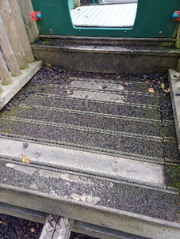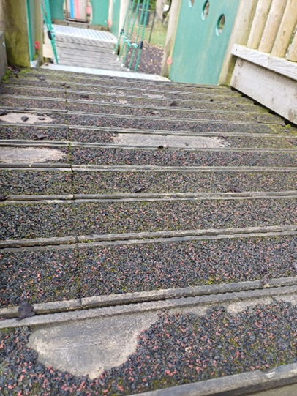
2
1

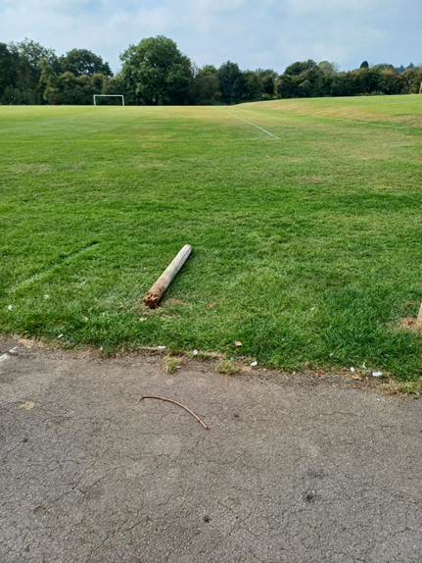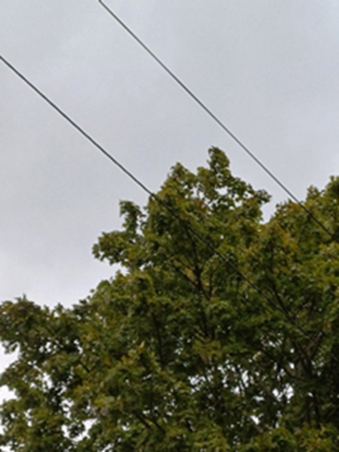
4
3

